**E-commerce website for HyperMarket**

**Project title :** E-commerce website for HyperMarket

**Operating System :** Windows

**Database :** MYSQL

**Technical Requirement’s :** Spring tool suit, VS Code

**Run Time Environment :**

**Backend :** SpringBoot , Rest API

**Frontend :** HTML, CSS, Angular, JavaScript, Bootstrap

**Summary**

The Hypermarket Ecommerce Website is an online platform designed to facilitate the purchase of various products within different categories.

It provides a user-friendly interface for customers to browse products, add them to their carts, and make purchases securely.

**ER Diagram**

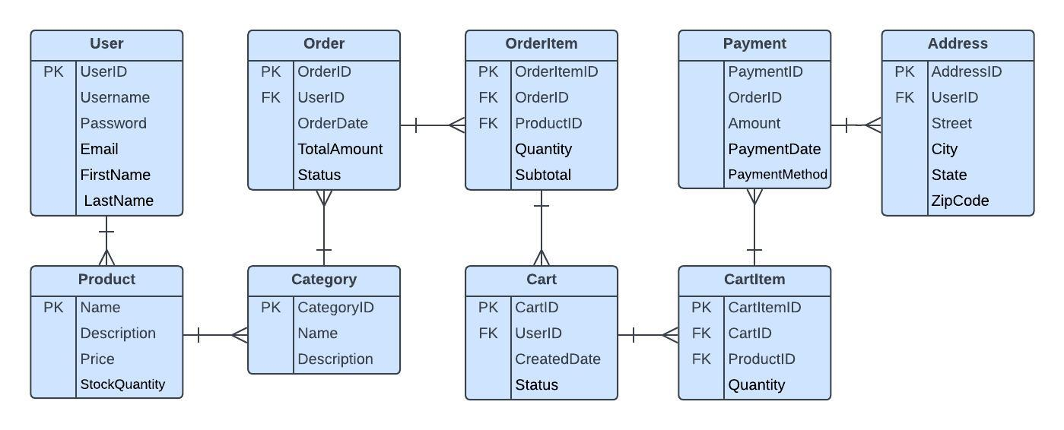

**Database design:**

- User table

CREATE TABLE User (

UserID INT PRIMARY KEY,

Username VARCHAR(255) UNIQUE,

Password VARCHAR(255),

Email VARCHAR(255) UNIQUE,

FirstName VARCHAR(255),

LastName VARCHAR(255)

);

-- Product table

CREATE TABLE Product (

ProductID INT PRIMARY KEY,

Name VARCHAR(255),

Description TEXT,

Price DECIMAL(10, 2),

StockQuantity INT

);

-- Category table

CREATE TABLE Category (

CategoryID INT PRIMARY KEY,

Name VARCHAR(255),

Description TEXT

);

-- Order table

CREATE TABLE Order (

OrderID INT PRIMARY KEY,

UserID INT,

OrderDate DATETIME,

TotalAmount DECIMAL(10, 2),

Status VARCHAR(50),

FOREIGN KEY (UserID) REFERENCES User(UserID)

);

-- OrderItem table

CREATE TABLE OrderItem (

OrderItemID INT PRIMARY KEY,

OrderID INT,

ProductID INT,

Quantity INT,

Subtotal DECIMAL(10, 2),

FOREIGN KEY (OrderID) REFERENCES Order(OrderID),

FOREIGN KEY (ProductID) REFERENCES Product(ProductID)

);

-- Cart table

CREATE TABLE Cart (

CartID INT PRIMARY KEY,

UserID INT,

CreatedDate DATETIME,

Status VARCHAR(50),

FOREIGN KEY (UserID) REFERENCES User(UserID)

);

-- CartItem table

CREATE TABLE CartItem (

CartItemID INT PRIMARY KEY,

CartID INT,

ProductID INT,

Quantity INT,

FOREIGN KEY (CartID) REFERENCES Cart(CartID),

FOREIGN KEY (ProductID) REFERENCES Product(ProductID)

);

-- Payment table

CREATE TABLE Payment (

PaymentID INT PRIMARY KEY,

OrderID INT,

Amount DECIMAL(10, 2),

PaymentDate DATETIME,

PaymentMethod VARCHAR(50),

FOREIGN KEY (OrderID) REFERENCES Order(OrderID)

);

-- Address table

CREATE TABLE Address (

AddressID INT PRIMARY KEY,

UserID INT,

Street VARCHAR(255),

City VARCHAR(255),

State VARCHAR(255),

ZipCode VARCHAR(10),

FOREIGN KEY (UserID) REFERENCES User(UserID)

);

**Team Members:**

**Shaikshavali**

**Roopa**

**Sushmitha**